CS570 – Software Testing

**HOP08A – Installing Wget**

11/22/2020 Developed by Kim Nguyen

Center for Information Assurance (CIAE) @City University of Seattle (CityU)

**Caution**

* If you already finished this module through any CityU School of Technology & Computing (STC) courses, just skim this module and skip it.
* Some version numbers may not match with the newly released ones. If so, stay with the most recent ones.
* This tutorial targets Windows OS and Mac users.
* We cannot explain every step. This cookbook always needs your own creative judgement. Try to solve the problem on your own, after a few tries, if you cannot solve the issue, contact TA for help.

**Learning Outcomes**

* + Install Wget to use with Selenium testing.

**Resources**

* Javapoint.come | Selenium WebDriver - <https://www.javatpoint.com/selenium-webdriver>

**For Mac Users**

Open Terminal, type the following to install using homebrew:

brew install wget

If you do not have brew installed, follow this instruction before proceed: <https://github.com/KimNguyenMai/Documentations/blob/master/Install%20Homebrew%20Guide.md>

1. Once the installation is completed, type the following to test download a file:

wget <https://testpages.herokuapp.com/styled/download/download.html>

A file named download.html should be downloaded to your current working directory.

Before you proceed further don't forget to delete the downloaded file.

**For Windows Users**

1. Go to <https://sourceforge.net/projects/gnuwin32/> and the download should begin automatically, if not, click “Download”

If the above url link does not work, try this: <https://eternallybored.org/misc/wget/> (Download exe version)

1. Open command prompt, type path into the command prompt, you should see similar result:

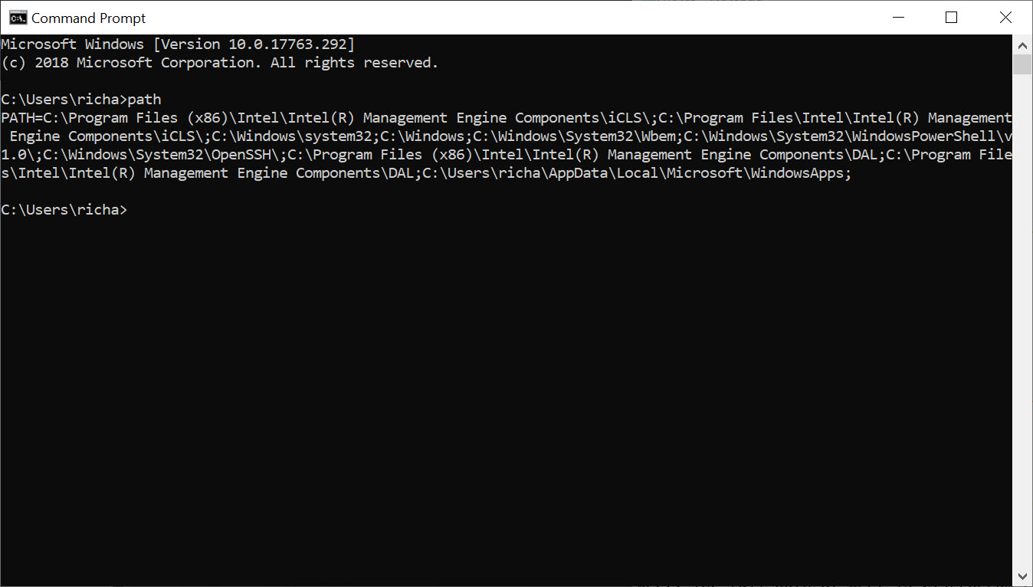

Thanks to the “Path” environment variable, we know that we need to copy wget.exe to the c:\Windows\System32 folder location.

Go ahead and copy WGET.exe to the System32 directory and restart your Command Prompt.

*[YOUR PATH MIGHT BE DIFFERENT]*

1. Once you have restarted command prompt, type the following to test download a file:

wget <https://testpages.herokuapp.com/styled/download/download.html>

You should see similar result:

A file named download.html should be downloaded to your current working directory.

Before you proceed further don't forget to delete the downloaded file.

**Once you have finish installing wget, move on to HOP08B document.**